Date:12.02.2022

**Third Year B. Tech., Sem VI 2021-22**

**Cloud Computing**

**Assignment submission**

**PRN No: 2019BTECS00064**

**Full name: Kunal Santosh Kadam**

**Batch: T2**

**Assignment: 1**

**Title of assignment: Implementation of RMI (Remote Method Invocation) Frameworks**

1. **Write a program in java for implementation of RMI Framework?**

Ans:

**Creating Interface:**

//define remote interface

import java.rmi.*;

public interface AddRem extends Remote

{

public int addNum(int a,int b) throws RemoteException;

}

**Implementation of Interface:**

//implementation of interface

import java.rmi.*;

import java.rmi.server.UnicastRemoteObject;

public class AddRemImpl extends UnicastRemoteObject implements AddRem

{

public AddRemImpl() throws RemoteException{}

public int addNum(int a,int b)

{

return a+b;

}

}

**Creating Server Side:**

//server program

import java.rmi.*;

import java.net.*;

import java.io.*;

import java.util.*;

public class AddServer

{

public static void main(String[] args) {

try

{

AddRemImpl locobj = new AddRemImpl();

Naming.rebind("rmi:///AddRem",locobj);

}

catch(RemoteException re)

{

re.printStackTrace();

}

catch(MalformedURLException mfe)

{

mfe.printStackTrace();

}

}

}

**Creating Client Side:**

//client program

import java.rmi.*;

import java.net.*;

import java.io.*;

import java.util.*;

public class AddClient

{

public static void main(String args[])

{

String host="localhost";

Scanner sc = new Scanner(System.in);

System.out.println("Enter the 1st Number");

int a = sc.nextInt();

System.out.println("Enter the 2nd Number");

int b = sc.nextInt();

try

{

AddRem remobj = (AddRem)Naming.lookup("rmi://"+host+"/AddRem");

System.out.println(remobj.addNum(a,b));

}

catch(RemoteException re)

{

re.printStackTrace();

}

catch(NotBoundException nbe)

{

nbe.printStackTrace();

}

catch(MalformedURLException mfe)

{

mfe.printStackTrace();

}

}

}

**Output:**

Executing .java files and Starting rmiregistry

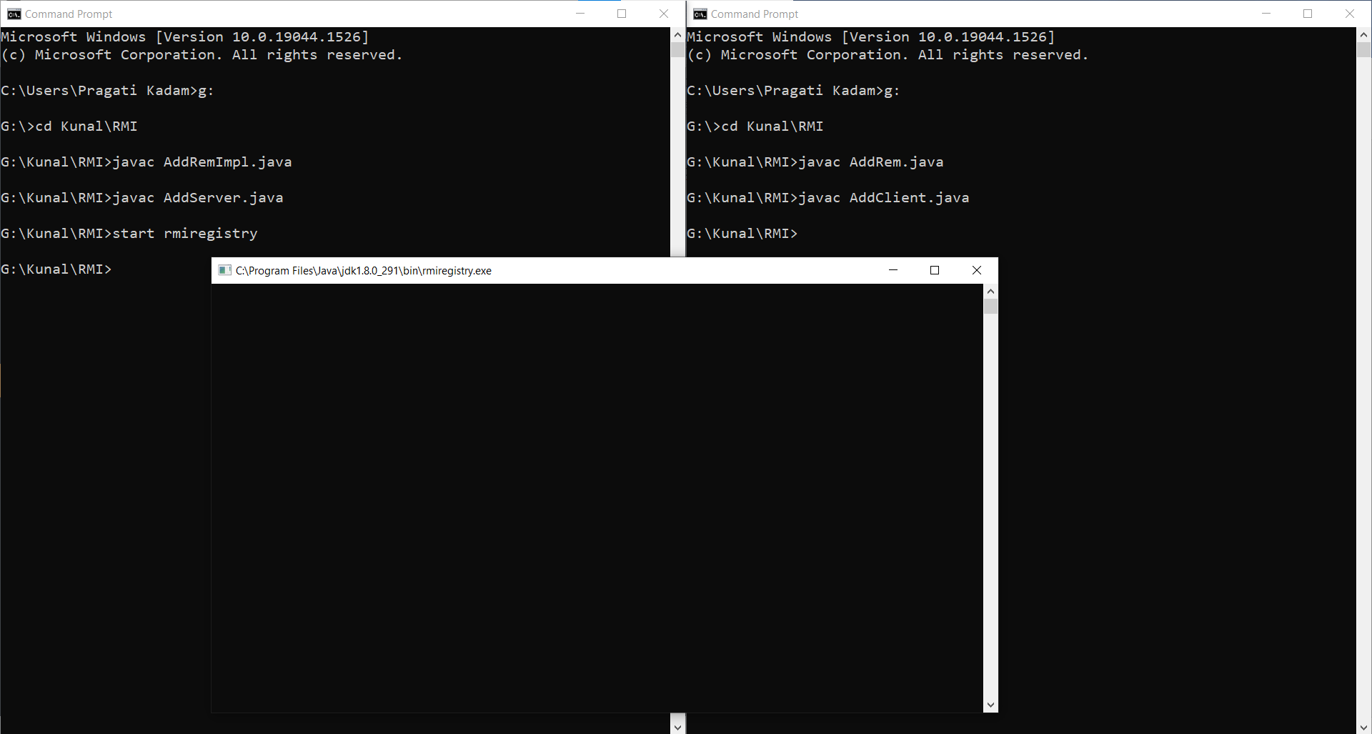

Running AddServer.java

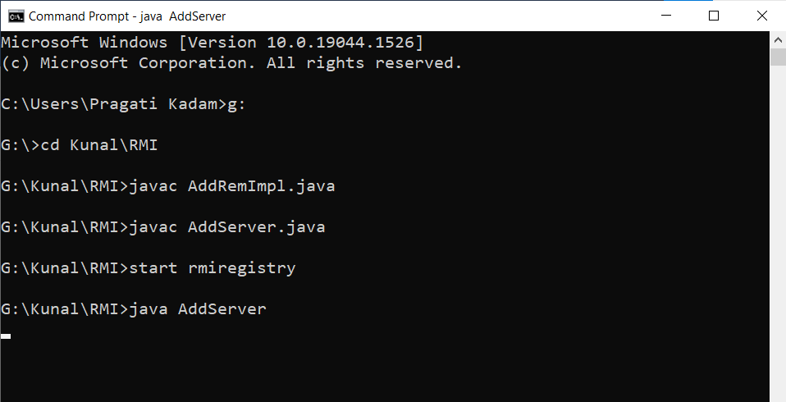

Running AddClient.java

